[November 2023] 1st Annual Symposium by Tokyo Camii Institute
Presenters Application Form

Name/of Representative, if a group
contact
Affiliation/grade or title
Subtheme number and title
(Working titles available)
abstract of your presentation:
About 800 Japanese characters / or about 400 English words
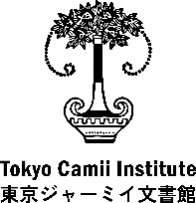
Please fill out this form and send it by email.
Tokyo Camii Institute – Symposium Secretariat
151－0065 3F, Oyama-cho 1-19, Shibuya-ku, Tokyo
E-mail: institute@tokyocamii.org

